CREATE YOUR OWN STANDING WORKSTATION
Prolonged static postures are very stressful on the body. And although most people tolerate a prolonged seated posture better than they tolerate prolonged standing, neither posture is desirable for prolonged periods. We fare so much better if we are able to move and change posture frequently.

The best solution is to use what is referred to as a sit-to-stand workstation or Adjustable-Height Workstation. These can be used in both seated and standing orientations, and can adjust to either height quickly and efficiently. If you work from home frequently, and commonly experience prolonged seated postures while doing so, it is in your best interest to consider acquiring one of these devices.

There are dozens of designs available to consumers. (Check out the other attachment provided in your email)

Build Your Own Standing Workstation
If you do not have the resources to purchase one of these devices, you can get the same value and benefit by creating a place to stand and work in addition to your seated work area. Then make frequent changes in your posture - no more than 45 minutes to 1 hr. max in either posture before switching to the other.

Applying the above suggestion will be impractical if it takes you a lot of time and effort to build or disassemble your standing workspace every time you wish to change postures. So, if you can create something that is efficient, it will have more value and you will use it more frequently.

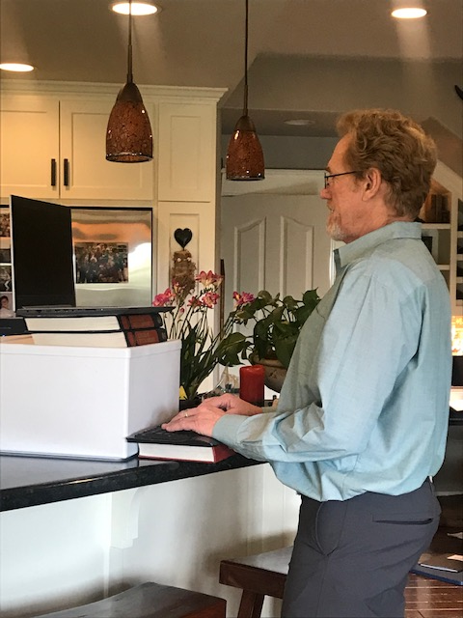
Here is a makeshift standing workstation.
It is made with a box and stacks of books and utilizes a remote keyboard and mouse. This achieves the desired goal of placing the keyboard and mouse at an ideal height for the hands/wrists/arms, while the monitor is at an ideal height for the head and neck.
This is built on a high counter which reduces the number and size of books and boxes needed. If placed on a standard- height desk, and/or if this set-up needs to be built and disassembled every time one changes posture, it will quickly be too burdensome, and won’t be utilized.

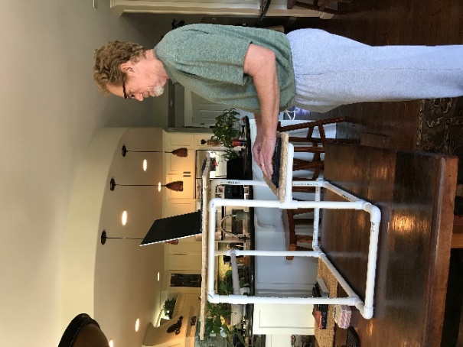
Here is a simple design for a standing workstation made of PVC pipe. It is very sturdy and light weight.

It can be placed on a desktop creating a perfect set-up for standing work, and if needed, it can quickly and easily be removed so the same desk can be used for seated work as well. It takes approximately 30 secs to convert from one to the other.

If you are so inclined to make one of these for yourself, everything you’ll want to know is provided below:

HOW TO MAKE A STANDING WORKSTATION FROM PVC PIPE
Total Cost: < $20.00
(note: this is the cost of PVC only. Does not include cost of saw or cutting tool or the plywood for the platforms)

Total time to build is approximately 1 hour

Tools required: a tool to cut the PVC – this could be a hand saw, a hacksaw, a circular saw or a PVC pipe cutter. (The PVC pipe cutter is preferred since cut piece will not require sanding.)

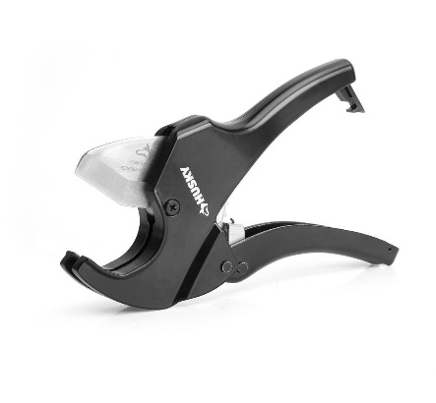
This is a picture of a PVC pipe cutting tool – it costs approximately $14.00 at Home Depot.

Instructions –

- Measure your workspace as well as your body:
Your workstation will not be easily height adjustable when completed. So, you’ll want to build it to be perfect for your use in the area in which you intend to use it.

Measure the following when you are standing at the location of intended use:

Hand height: this is the distance from the desktop to your hands when they are positioned in the optimal working posture. This is also known as the elbow height – (upper arms should hang relaxed by your torso, bend the elbows to 90º, keep the wrists in neutral position)

Eye height: this is the distance from your desktop to your eyes.

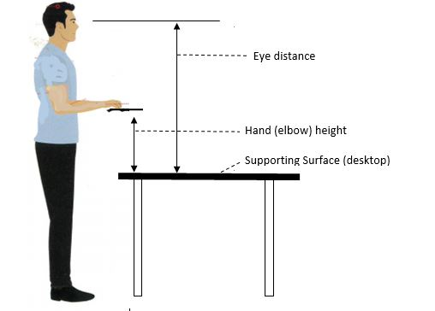

Also determine the supporting-surface area and your work surface areas:

The Supporting Surface: this is the area on which the standing workstation will be resting when in use. This can be whatever you decide it to be except that it should not be larger than the surface it will rest on and should not be significantly smaller than the Lap-top Work-Surface Area (see below.)

The Work Surfaces:
Laptop Platform: this is the area of the platform the laptop will rest on. This can also be whatever you decide but should probably stay within the recommended range of
Width: 20 - 24 inches X Depth: 10 to 15 inches

Keyboard/ Mouse Platform: this is the area of the platform that the remote keyboard and mouse will rest on. The following range is recommended:
Width 24 - 26 inches x Depth 8 - 10 inches

Height of Computer Monitor or Laptop Screen:
Lastly, also measure the height of the laptop screen or other monitor that you will be viewing.

2. Calculate Material Needed

The amount of PVC pipe you will need is dependent on the size of the frame you are making, which is also dependent on the measurements described above. For most people at most desks, two (2) ten-foot (10’) lengths of pipe (20’ total) will suffice. Use the table below to figure out materials and create a stand that is customized for you.

Note: The critical pieces are the ones that determine the height of your work surface platforms (see above). To get these lengths correct we must take into account various construction factors (C-Factors) such as the added height created by the couplings, as well as the thickness of the platforms, the height of the monitor etc. So, subtract the values as indicated in the table to calculate the proper length of all pieces

Other pieces are less critical and can be increased if desired to create a larger stand. Values for these less critical pieces are pre-entered into the table and are appropriate for a Laptop Platform of 15” x 24”; and a keyboard platform of 10” x 24”

 | Critical Height Pieces – determine from measurement of your body and the supporting surface
Part Label | Part Name | Your Measurements | C-Factor | Total Length of Piece
D | Front Post - Bottom Left | enter “Hand Ht.” | minus 5 inches
D | Front Post - Bottom Right | enter “Hand Ht.” | minus 5 inches
E | Front Post - Top Left | enter “Eye Ht.” minus “Hand Ht.” | minus Laptop Screen, minus 3 inches
E | Front Post - Top Right | enter “Eye Ht.” minus “Hand Ht.” | minus Laptop Screen, minus 3 inches
F | Back Post- Left | Must equal height of Front Post-Left; top + bottom (two pieces) | minus 3 inches
F | Back Post- Right | Must equal height of Front Post-Right; top + bottom (two pieces) | minus 3 inches
 | Less Critical Pieces – determines width of frame and platforms (Recommended dimensions shown)
Part Label | Part Name | Recommended | C-Factor | Total Length of Piece
A | Base - Front | 16 |  | 16
A | Base - Rear | 16 |  | 16
B | Base - Front extension -L | 3 |  | 3
B | Base - Front extension -R | 3 |  | 3
B | Base – Rear extension -L | 3 |  | 3
B | Base – Rear extension -R | 3 |  | 3
C | Base - Side-Left | 12 |  | 12
C | Base - Side-Right | 12 |  | 12
C | Top Bar - Left | 12 |  | 12
C | Top Bar - Right | 12 |  | 12
B | Back Post Extension - L | 3 |  | 3
B | Back Post Extension - R | 3 |  | 3
A | Top Horizontal Brace- Rear | 16 |  | 16
G | Keyboard Tray - Sidearm-L | 7 |  | 7
G | Keyboard Tray - Sidearm-R | 7 |  | 7
A | Keyboard Tray - Front | 16 |  | 16
 | Total Length of all pieces in inches
 | (Divide above total by 12 to determine number of feet of pipe needed)
 | Couplings
H | Right Angle (90º) – elbows 10 Pieces |  |  | 10
J | Tee-coupling 8 Pieces |  |  | 8

When you’ve cut your pipe into the component parts you should have something like this:

Back Posts- “F” (2) Extensions- “B” (6) Base Sides and Top Bars- “C” (4)

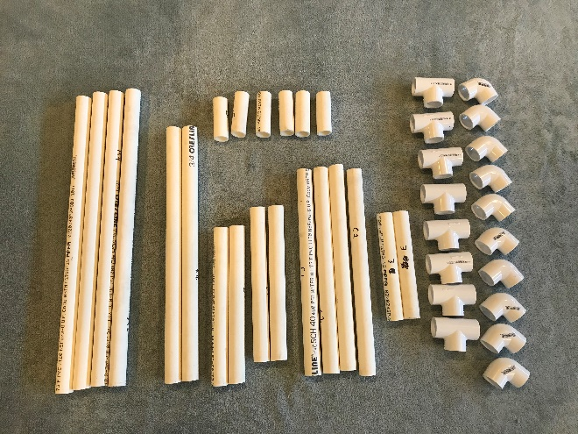
Couplings:

Right Angle (elbows)
“H” (10)

Tee-couplings
“J” (8)

Base Front,
Base Rear,
Top Horizontal Brace
Keyboard Tray Front-
“A” - (4)
Front Post Bottom “D” (2) Keyboard Tray Sidearm “G” (2)

Front Post Top “E” (2)

Assembly Instructions: (Note: It is not necessary to use pipe joint glue to assemble this project. Do NOT use glue.)

- BUILD THE BASE:
  - Cut the pipe into the various lengths as determined by your measurements and the completed table. Refer to the Part Label as listed in the table above to follow assembly instructions.
  - Connect a Tee-coupling (J) to both ends of both the Base-Front (A), and the Base Rear (A).
  - Insert extension pieces (B) into the opposite end of the Tee-couplings on the Front and Rear bases.
  - Connect a Right Angel elbow coupling (H) to the ends of all four extension pieces.
  - Connect Base Sides L and R (C) to the elbow couplings connected to the Base Front. Rotate the Base-Sides to face the Base-Rear and connect them to the elbow couplings attached to the Base- Rear. Manipulate the resulting square so that all four sides are in the same plane and the Tee-couplings all face up.

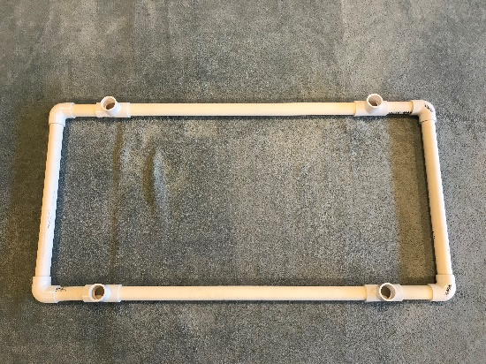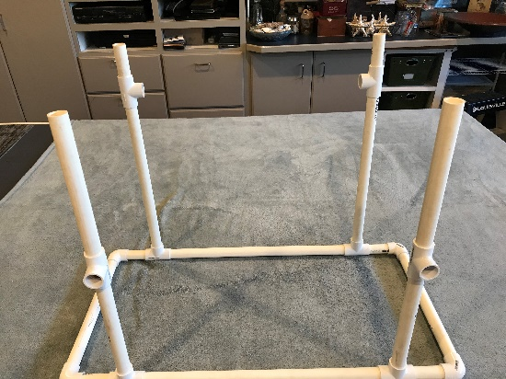

Assembled Base

Installed Posts
(Front)

- INSTALL THE POSTS:
  - Insert the Front Post-Bottoms, Left and Right (D) into the T-couplings on the Base-Front. Connect a Tee-coupling (J) to the open end of each Front Post-Bottom and rotate the Tee opening to face away from the frame. Connect the Front Post-Tops (E) to the opposite end of the Tee-coupling.
  - Connect the Back Posts (F) to the Tee-couplings that are connected to the Base-Rear.
  - Connect a Tee-coupling (J) to the top of each Back-Post and rotate Tee-openings to face each other.
  - Insert extensions pieces (B) into the Tee-couplings on the Back Posts. (All four posts should now be equal in height.)

- CONNECT THE TOP HORIZONTAL BRACE AND THE TOP BARS
  - Connect the Top Horizontal Brace-Rear (A) to the Tee-couplings on the Back Posts
  - Connect elbow couplings to both ends of both Top Bars (C).
  - Connect the Top Bar-LEFT to both the Front Post-Left and the Back Post-Left; Connect Top Bar-Right to both the Front Post-Right and the Back Post-Right.

- CONNECT THE KEYBOARD TRAY
  - Insert the Keyboard Tray-Sidearms (G) into the Tee-couplings on the Front Posts.
  - Connect a Right Angel elbow coupling (H) to each end of the Keyboard Tray Front (A). Connect the Keyboard Tray Front to both Side Arms.

Top Bars and Horizontal Brace assembled.

Keyboard Tray Assembled
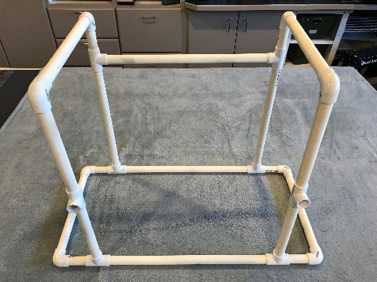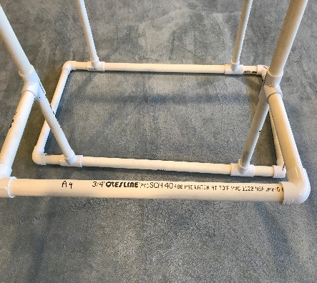

- PLACE WORK SURFACES ON FRAME
  - Cut desired dimensions of your work-surfaces (both the platform for the laptop (or monitor) and the platform for the keyboard tray. This can be plywood or other flat surface material)
  - Place work surfaces on the PVC frame and you’re done.

Note: The surface area of the platform that supports the laptop, should also be large enough to support any commonly used materials of work such as hard-copy documents, or files, a calculator, etc.

The surface area of the keyboard tray should be large enough to accommodate both the remote keyboard and the mouse. 24 inches wide X 10 inches deep is a recommended minimum.

COMPLETED STANDING WORKSTATION
This project was built with Schedule 40, ¾ in. ID pipe. You can also use ½ in. ID pipe.
¾ in. pipe is harder to cut, but a little sturdier.
Note: Once completed, if you determine that either of your work surfaces are too high, or too low, simply dismantle and re-cut the lengths of the post pieces as necessary to properly customize your project.
